

Master of Science Course in Mechanical Engineering

Control and Actuating Devices for Mechanical Systems

Enrico Gussoni – 807939

MatLab Exercise: PID regulators

System:

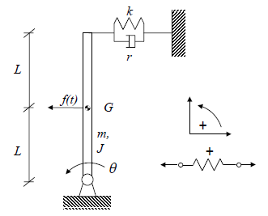
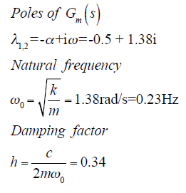
L=1; % [m]
m=80; % [kg]
J=2; % [kg*m2]
r=25; %[Ns/m]
g=9.81; %[m/s2]
k=125; %[N/m]

kp = 0:250:1000

td = 0.1 (kd = kp*td)
ti = 10 (ki = kp/ti)

Case 1) k = 125 N/m ; Poles of the uncontrolled system in -2.5706 and 1.3511 → P = 1

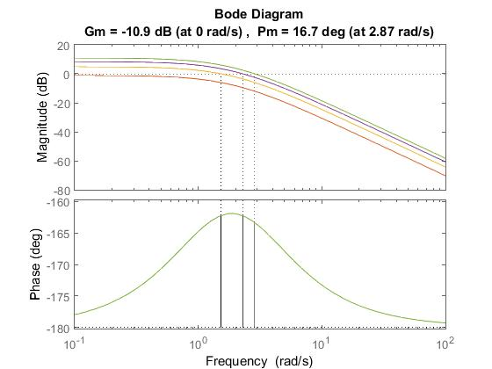 | 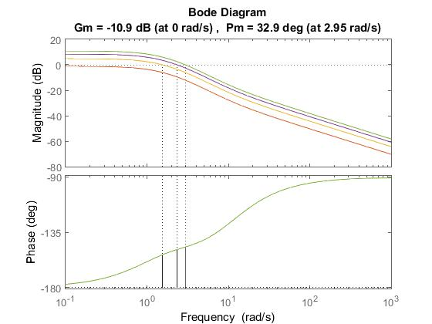 | 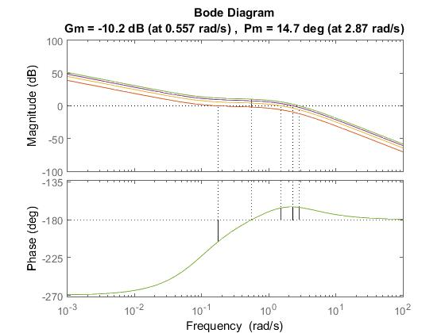
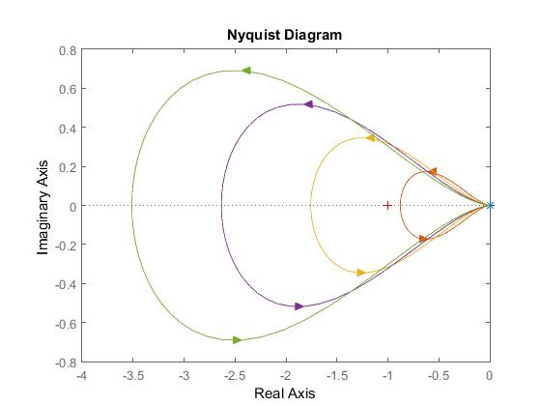 | 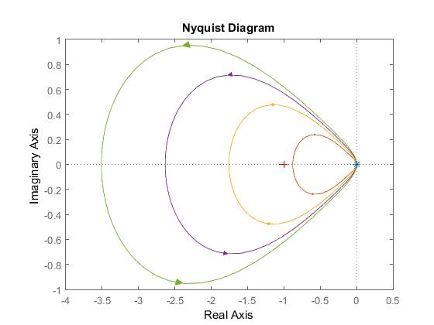 | 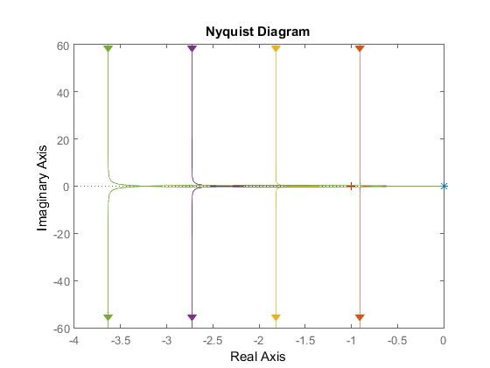
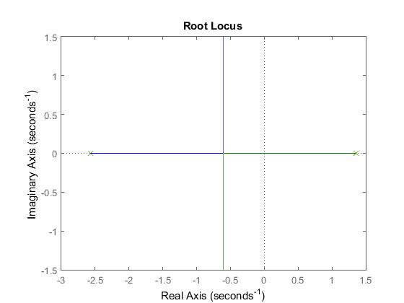 | 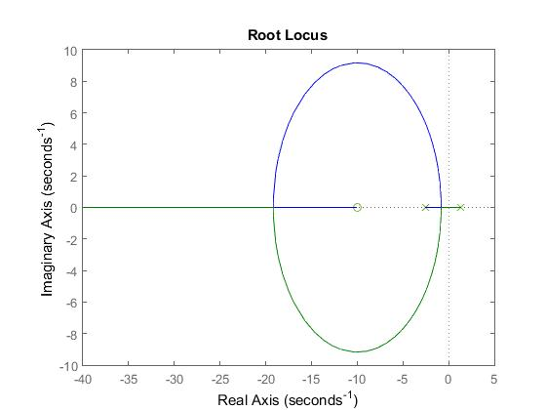 | 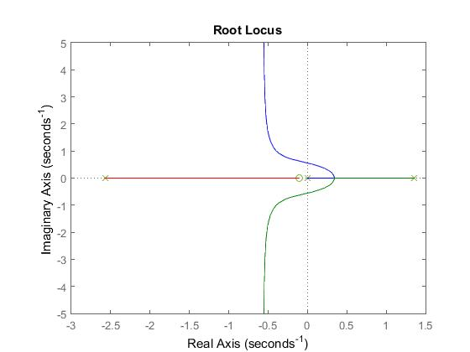
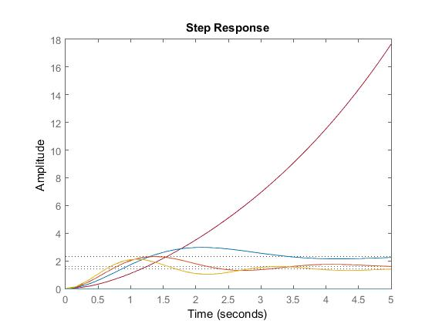 | 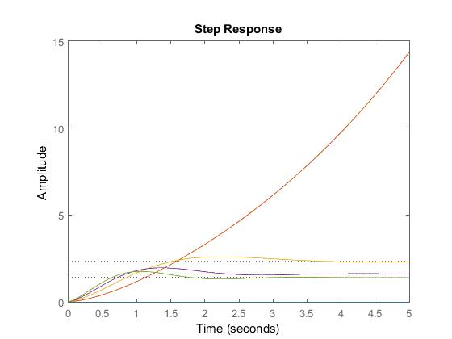 | 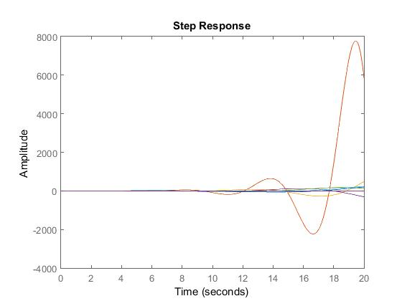

Case 2) k = 196.2 N/m ; Poles of the uncontrolled system in -1.2195 and 0.0000 → P = 0

Proportional | Proportional Derivative | Proportional Integral
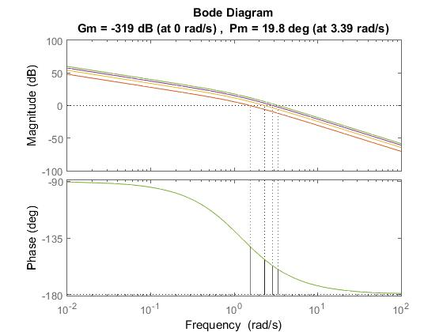 | 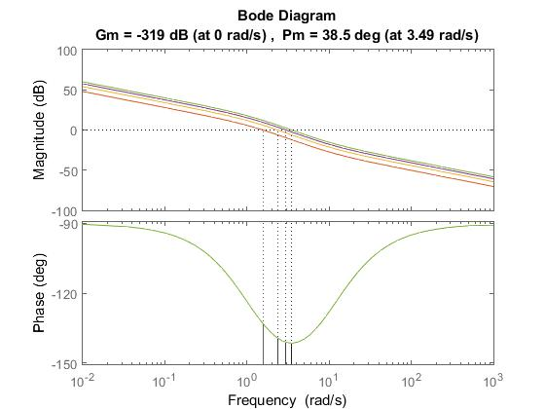 | 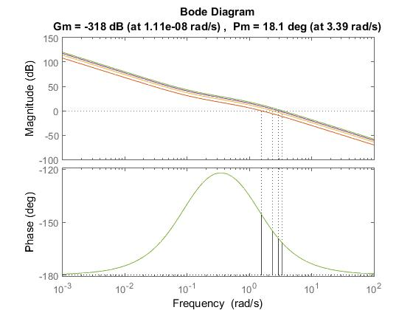
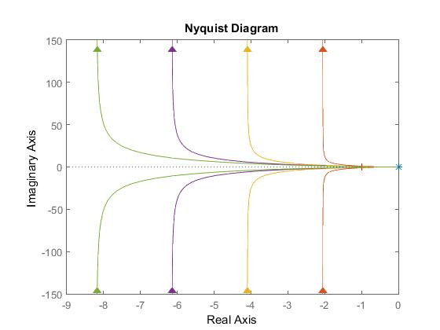 | 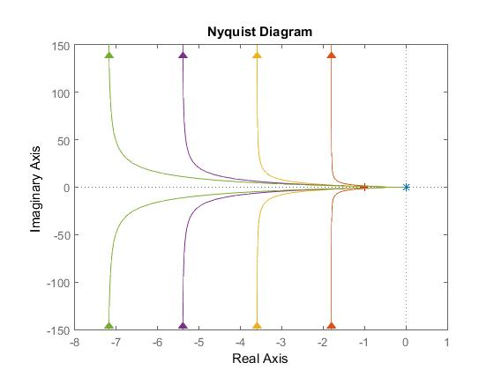 | 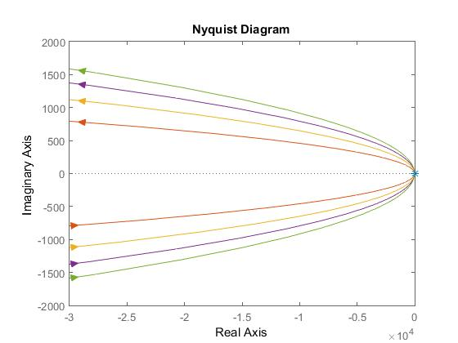
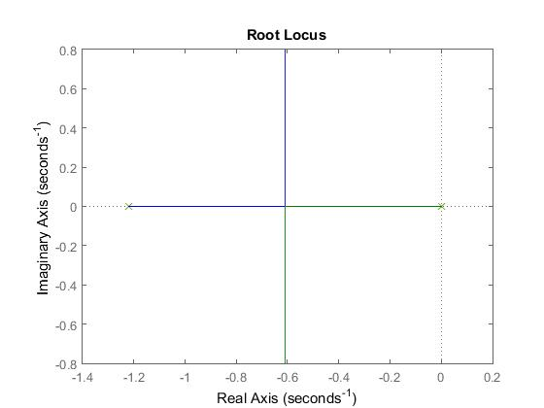 | 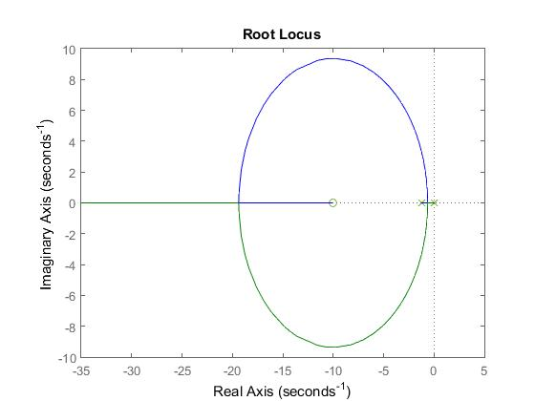 | 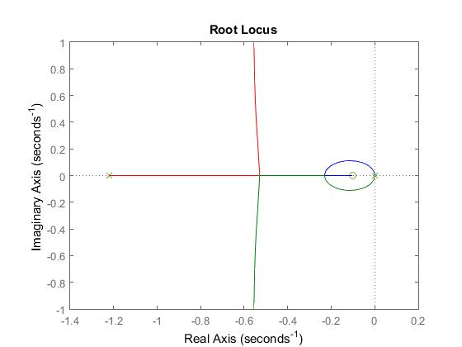
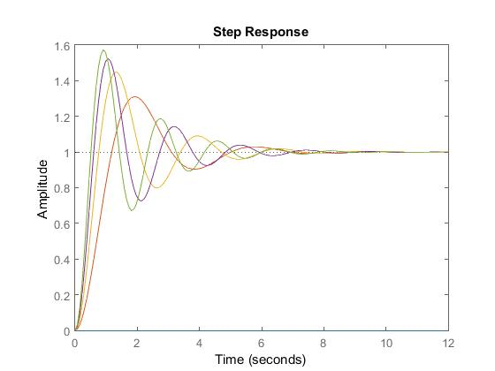 | 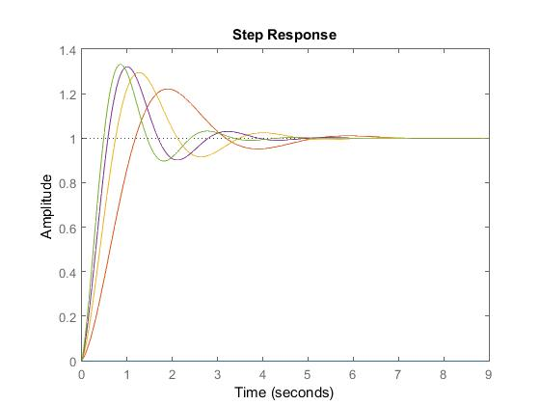 | 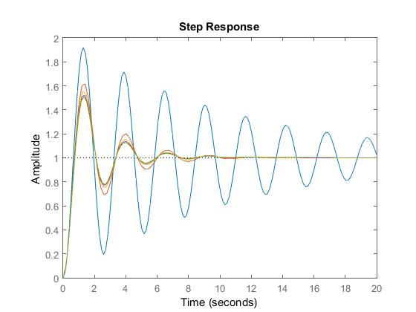

Case 3) k = 250 N/m ; Poles of the uncontrolled system in (-0.6098 + 1.5009i) and (-0.6098 – 1.5009i)

Proportional | Proportional Derivative | Proportional Integral
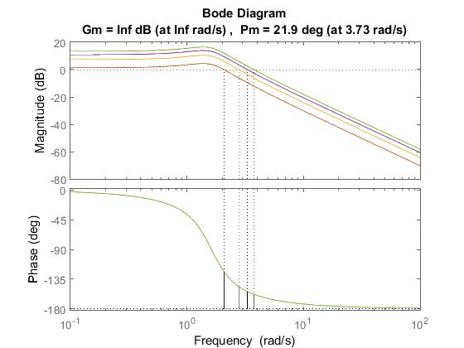 | 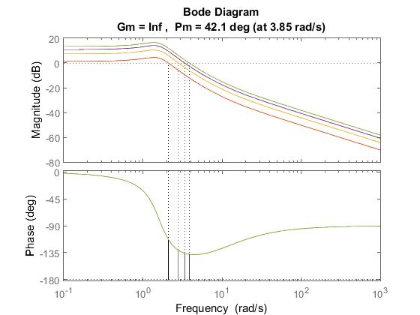 | 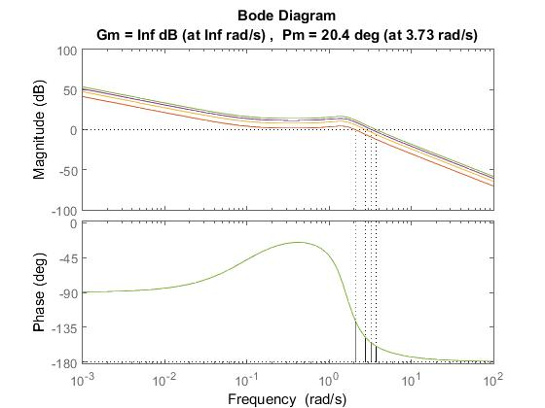
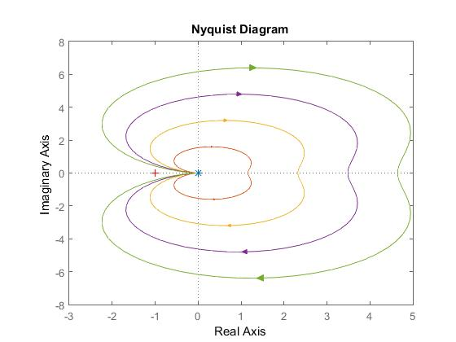 | 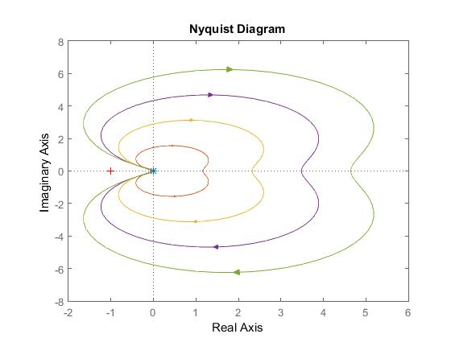 | 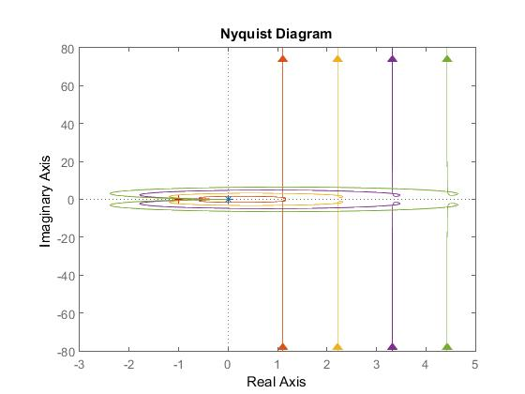
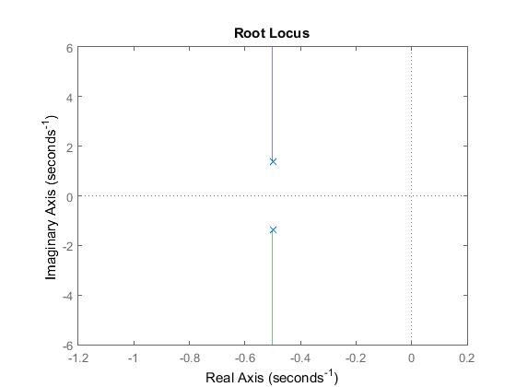 | 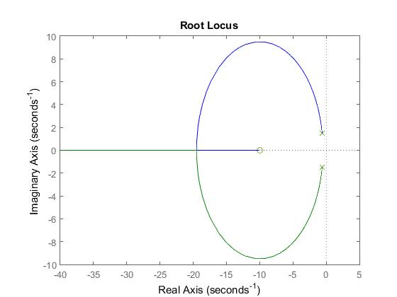 | 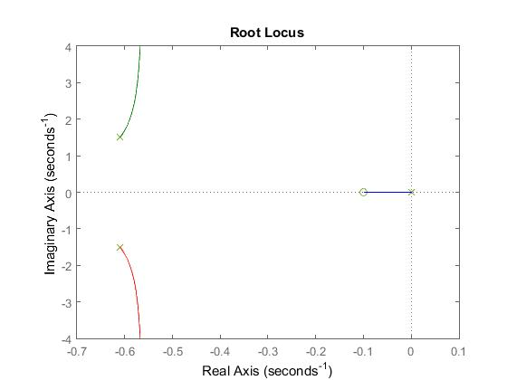
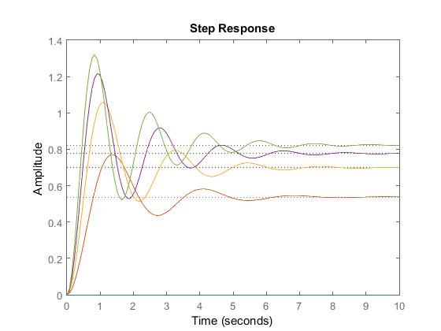 | 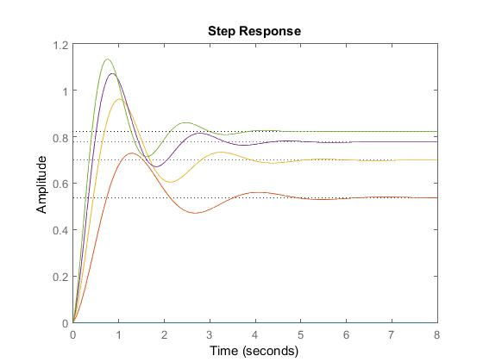 | 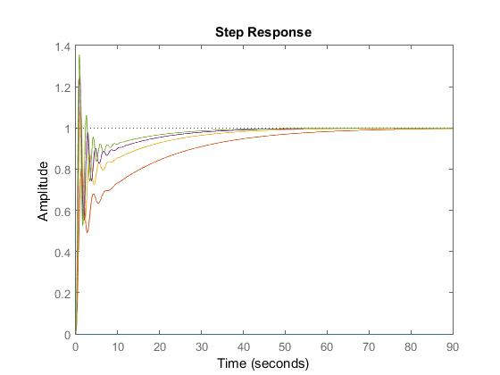

Case 4.1) k = 125 N/m ; kp = 250; Td = 0,1🕑🕑🕑🕑:0,2:1

Proportional Derivative
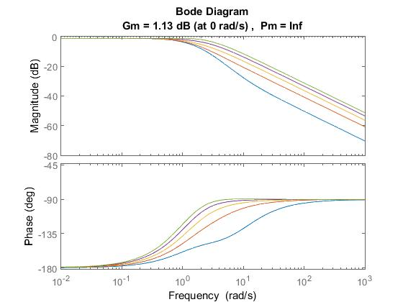 | 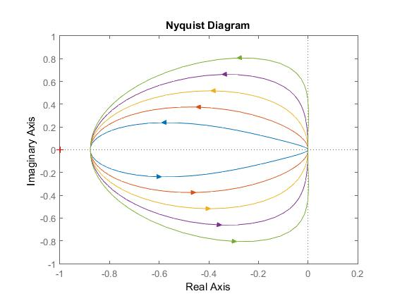 | 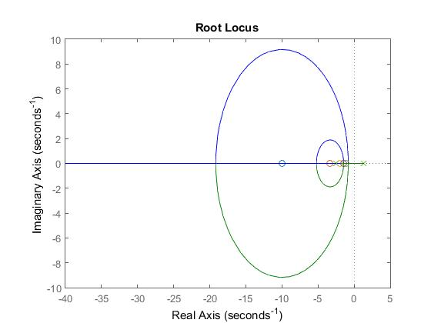 | 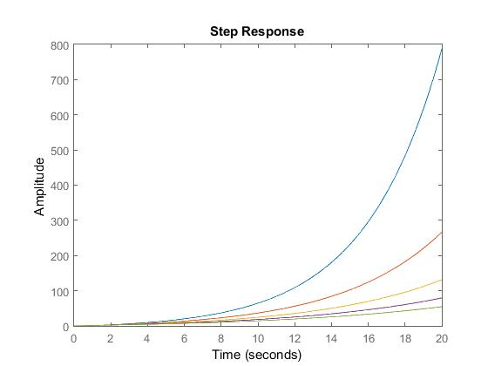

Case 4.2) k = 196.2 N/m ; kp = 250; Td = 0,1🕑🕑🕑🕑:0,2:1

Proportional Derivative
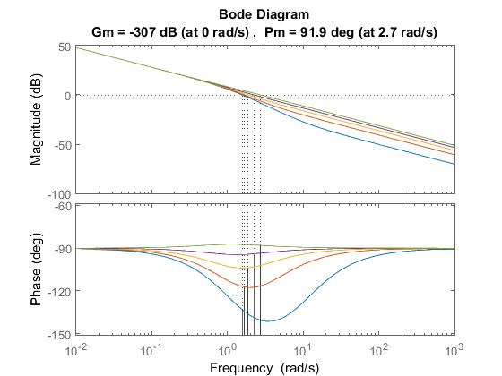 | 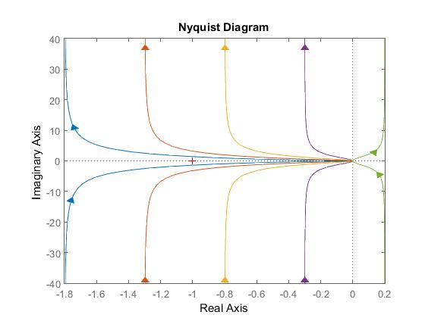 | 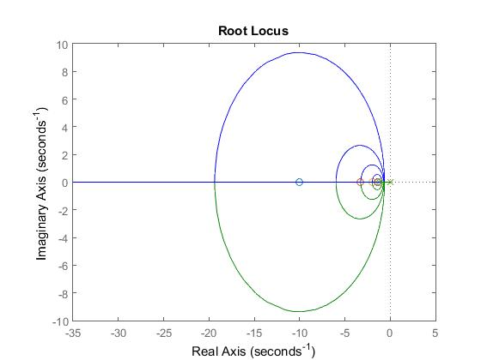 | 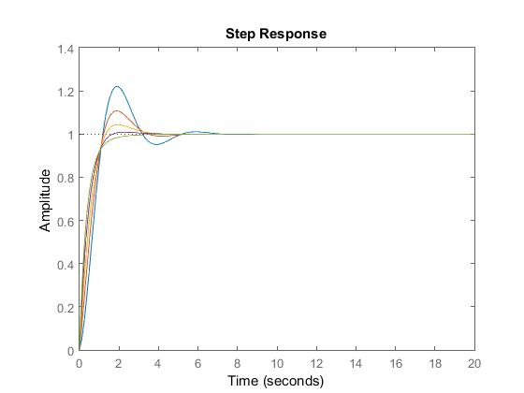

Case 5.1) k = 125 N/m ; kp = 250; Ti = 1🕑🕑🕑🕑:2:10

Proportional Integral
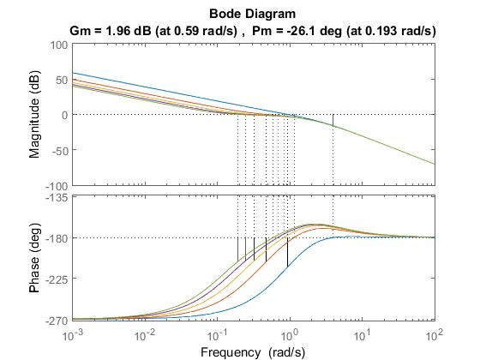 | 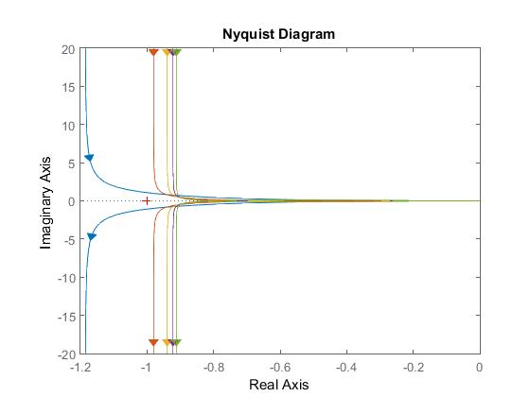 | 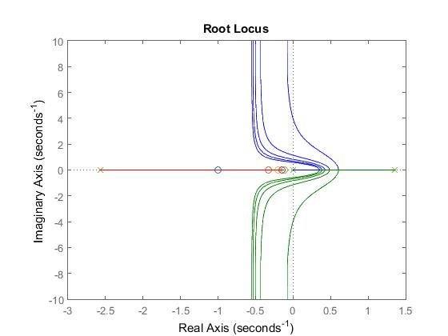 | 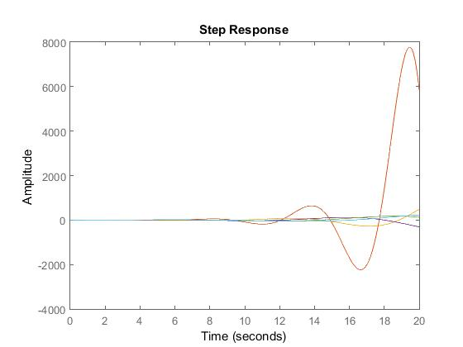

Case 5.2) k = 196.2 N/m ; kp = 250; Ti = 1🕑🕑🕑🕑:2:10

Proportional Integral
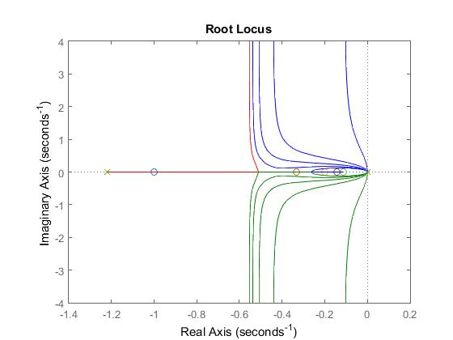

MatLab Exercise: 2 degrees of freedom systems

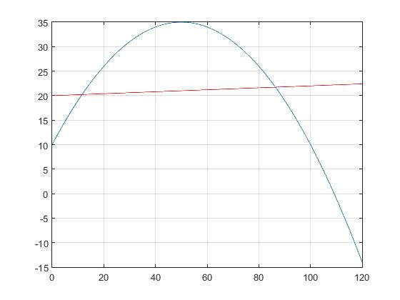
Jm = 0.01; % [kg*m2] motor inertia
Jr = 0.15; % [kg*m^2] load inertia
r = 0.01; % [Nms/rad] damping
kt = 1000; % [Nm/rad] torsional spring

Cr = 20; % [Nm] constant
Cm = (alfa*omega^2 + beta*omega + gamma)*y
Cm = [-0.01 1 10]; % [Nm] coefficients alfa, beta,gamma
y0 = 1; % input variable at the equilibrium

Case 1) Rigid shaft → 1 degree of freedom system

Case 2) Non rigid shaft → 2 degrees of freedom system

Case 2.2) Co-Located control

Case 2.3) Non Co-Located control
Case 1.1) Stable case

Proportional | Proportional Derivative | Proportional Integral
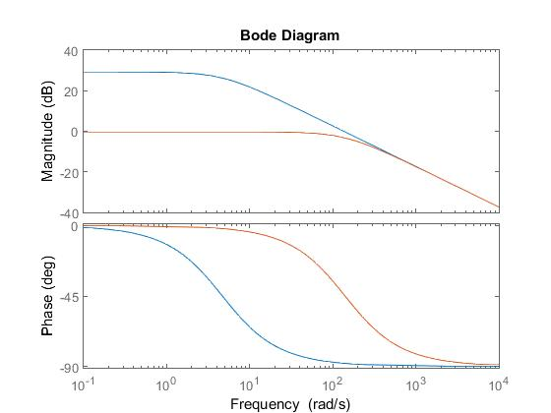 | 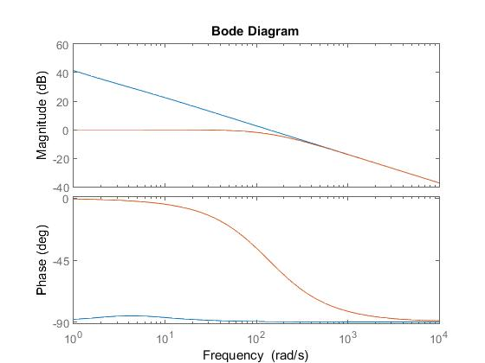 | 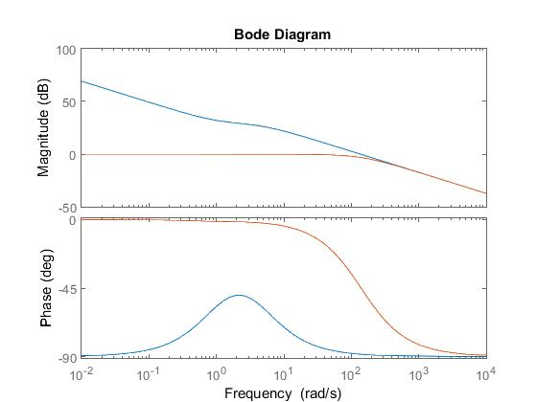
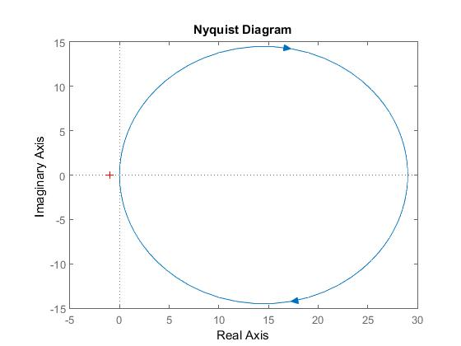 | 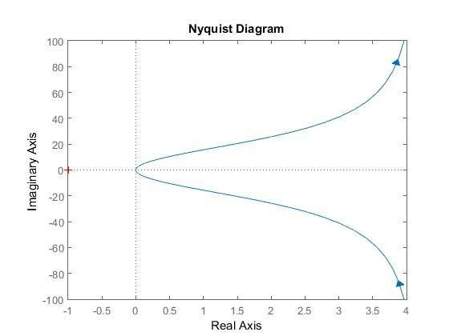 | 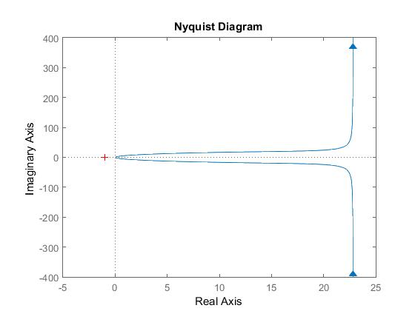
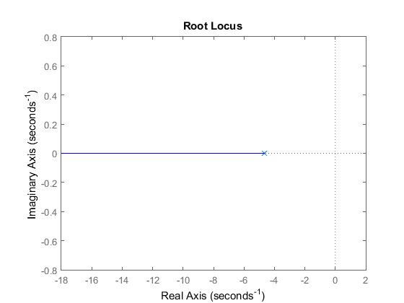 | 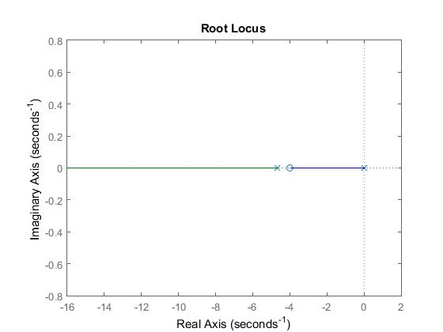 | 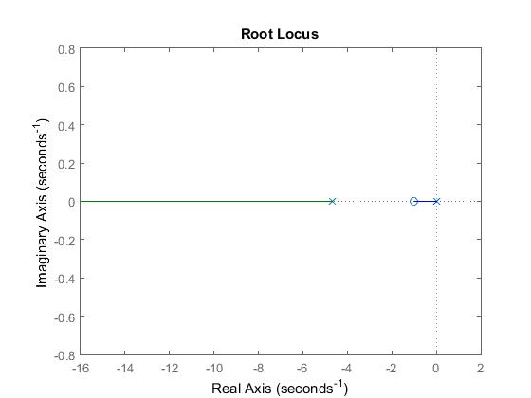
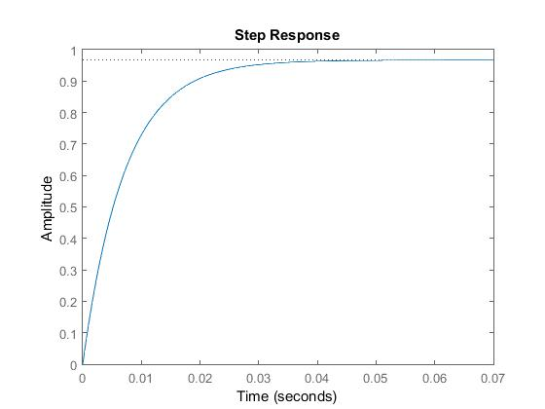 | 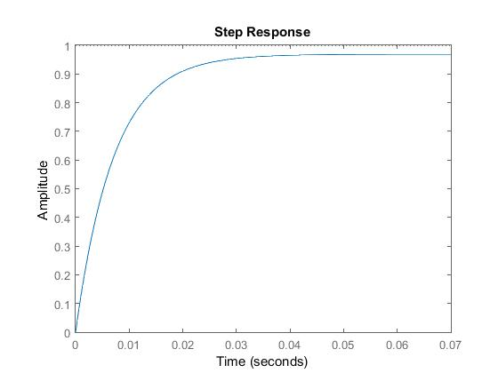 | 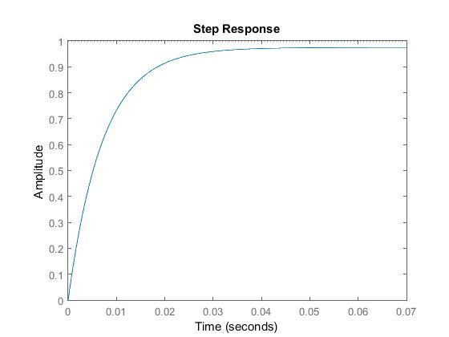

Case 1.2) Unstable case

Proportional | Proportional Derivative | Proportional Integral
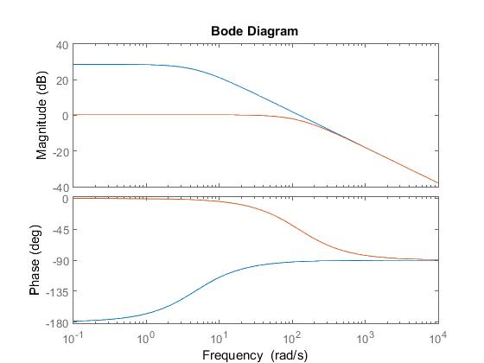 | 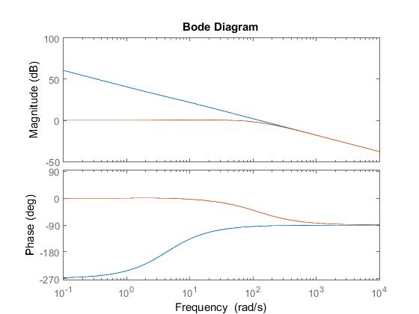
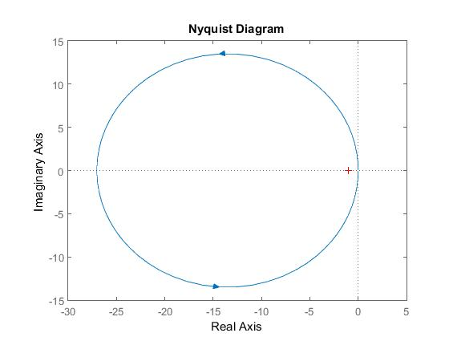 | 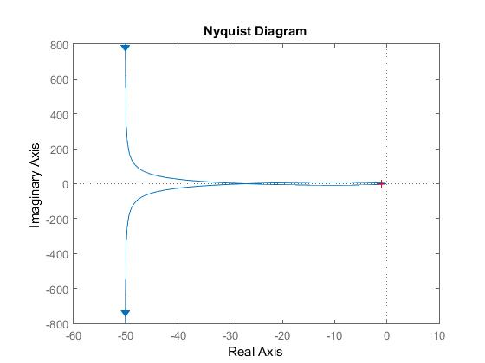
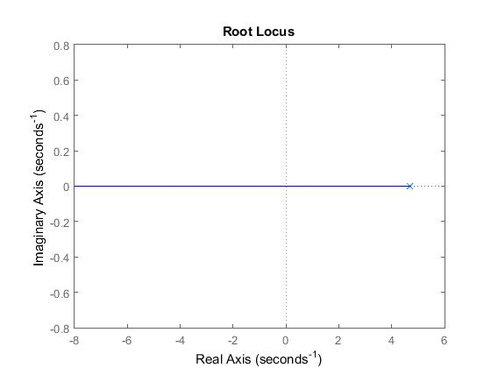 | 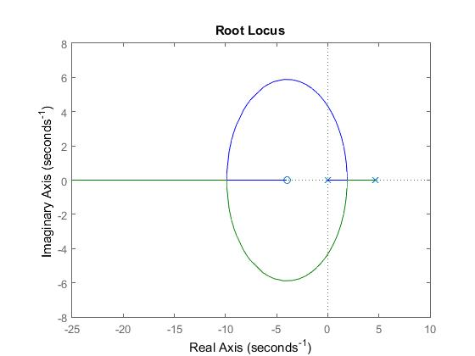
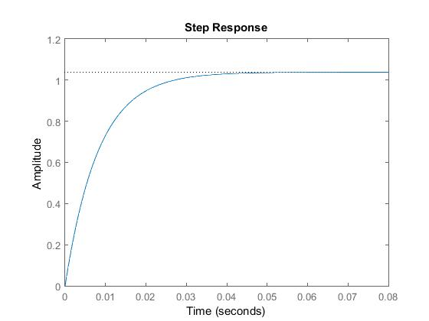 | 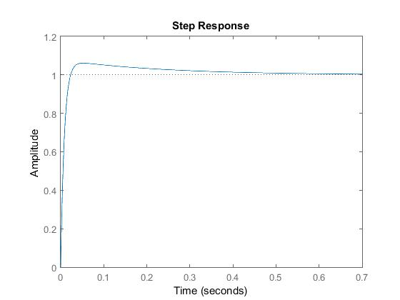

Derivative is not so useful in this case: it add one zero and so the slope of the bode diagram at high frequencies will be 0 => no attenuation

